1.



2.



3.

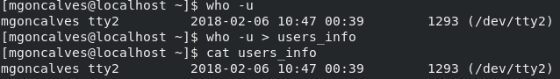

4.



5.

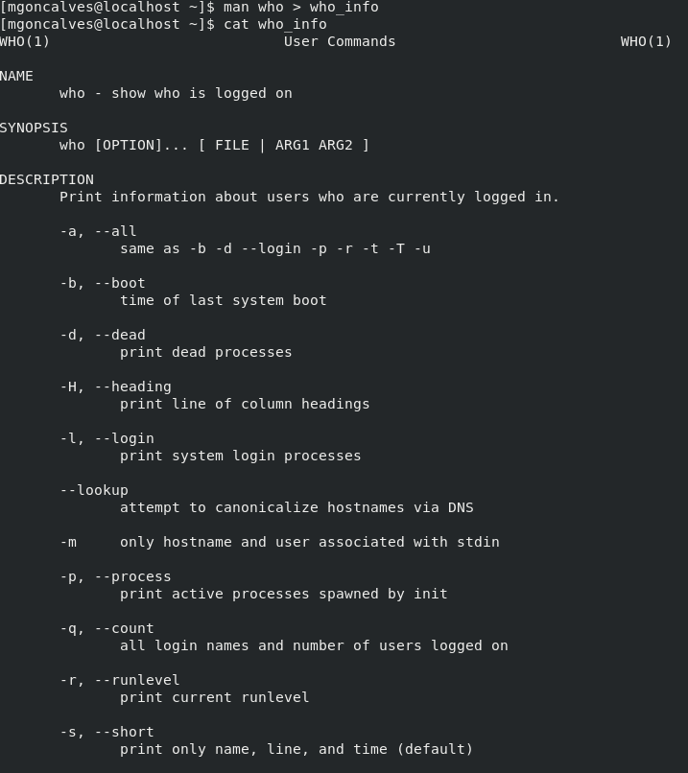

less who_file

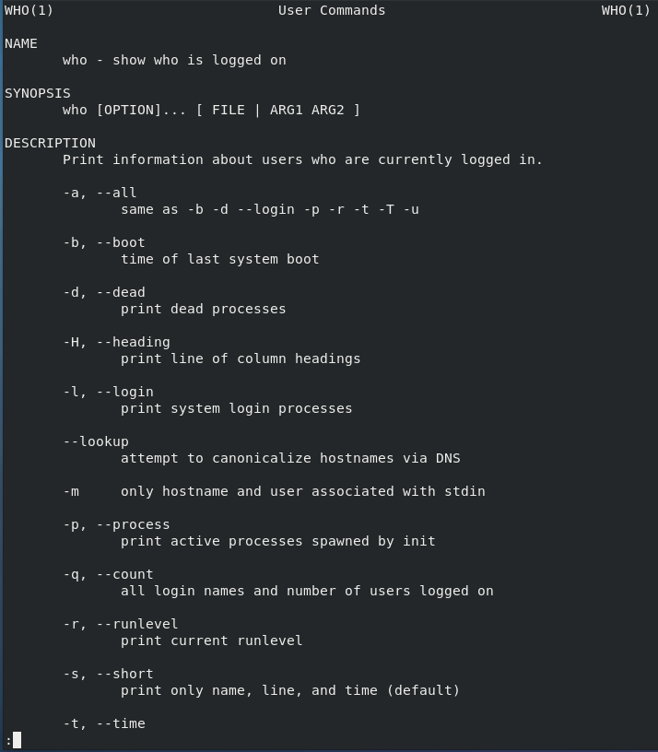

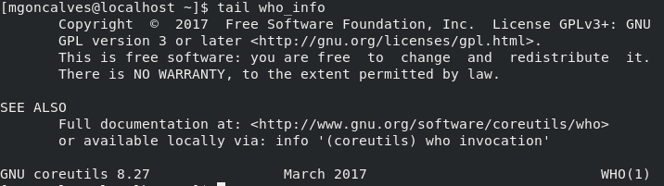

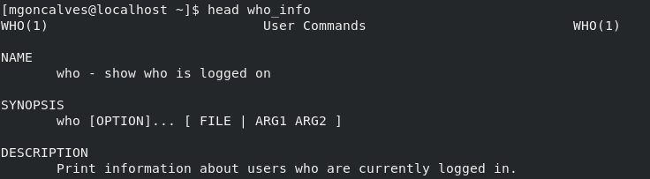

6.

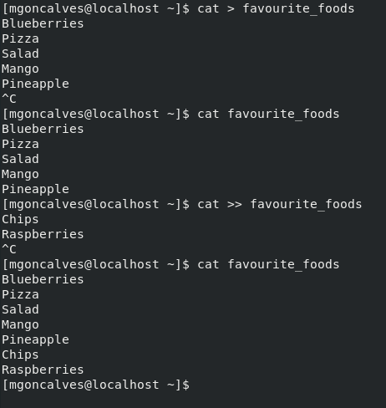

7.

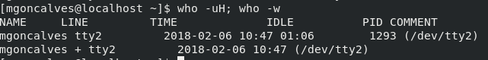

8.



9. 10 lines.

10. 10 lines.